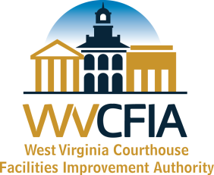
West Virginia
Courthouse Facilities Improvement Authority Fund
19th Cycle - Progress Report
County Name: | Grant ID #:
Mailing Address: | Report Period:
Report Completed By:
Title:
Telephone #:
Email Address:
Please describe activity, progress, achievements, and difficulties encountered below. If you have not expended any grant funding, please give an explanation of why. PLEASE BE DESCRIPTIVE. Reports must be submitted at the end of each quarter. Reports are due by the 20th of the month following each quarter. Therefore, a progress report is due by April 20th, July 20th, October 20th and January 20th. More than 1 delinquent project report may result in funding restrictions or grant termination. In addition, a progress report must accompany all reimbursement requests. Email submission of this report is preferred. Send to melissa.smith@wvcfia.com.

