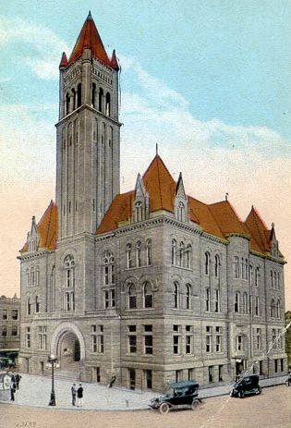
Courthouse Facilities
Improvement Authority

Agenda
December 15, 2017
10:00 a.m. – Conference Call

- Roll Call/Establish Quorum/Approval of Minutes/Introduction of Guests

- Reports and Considerations

  - Financial Update
  - Grant Update
  - Executive Director’s Report

- Old Business

- New Business
- Pcard approval
- Time Extension Requests:
13th cycle grant – Ohio (12/31/18)
14th cycle grants –
January 31st: Monroe
Feb. 28th requests: Gilmer, Tucker, Wayne, Webster
March 30th: Cabell
March 31st: McDowell
April 13th: Berkeley
August 30th: Hardy

- Executive Session
- Good of the Order

- Next Meeting

Agenda and Order of the Agenda are Subject to Change
For Updated Agenda Information, please call 304-558-5435

Executive Director’s Report

- All new 15th cycle grant contracts and informational documents have been mailed out to counties.

