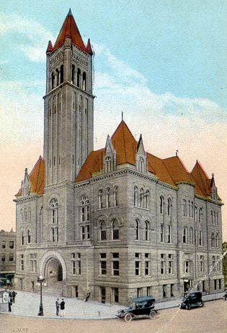
Courthouse Facilities
Improvement Authority

Agenda
April 18, 2018
10:00 a.m. – Conference Call

- Roll Call/Establish Quorum/Approval of Minutes/Introduction of Guests

- Reports and Considerations

  - Financial Update
  - Grant Update
  - Executive Director’s Report

- Old Business

- New Business
- Pcard approval
- Annual Pcard Report
- Emergency Grant Request: Monroe County
- Time Extension Requests:
14th cycle grants –
October 19^{th:} Pendleton Co.

- Executive Session
- Good of the Order

- Next Meeting

Agenda and Order of the Agenda are Subject to Change
For Updated Agenda Information, please call 304-558-5435

Executive Director’s Report

- Management Succession Policy
- Bid Opening tomorrow for architect for office water infiltration project
- Interviews with top 3 firms on April 26th
- August 3rd – Grant Training at the Embassy Suites in Charleston (Will do 2 more at regional locations around the state. Used to team up with WVACo. Going to contact them or the Commissioners’ Assoc. to see if I can do that again this summer.)

