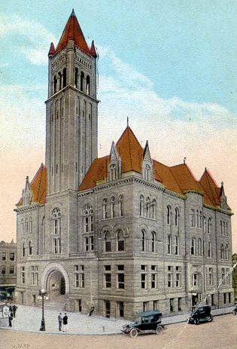
Courthouse Facilities
Improvement Authority

Agenda
June 1, 2016
10:00 a.m. – Judge L. D. Egnor Conference Room

- Roll Call/Establish Quorum/Approval of Minutes/Introduction of Guests

- Reports and Considerations

  - Financial Update
  - Grant Update
  - Executive Director’s Report

- Old Business

- New Business
- Pcard approval
- Time Extension Requests: Wirt (6/30)
- FY17 Budget

- Executive Session
- Good of the Order

- Next Meeting

Agenda and Order of the Agenda are Subject to Change
For Updated Agenda Information, please call 304-558-5435

Executive Director’s Report

- OASIS update – payroll went live on May 14; May be some travel reimbursements delayed. Board members must now be entered into the system as “employees”. This should be the final step for our agency to be fully converted to the OASIS system.
- Teaming with WVACo for regional meetings. June 9th in Morgantown and June 10th in Logan. Will do two other, more detailed grant trainings with one of those being in Logan, as well, and another location in the north. These will not be planned until the Legislature passes a budget bill.
- Brick repointing project update.
- Vacation week of June 13

